I have been trying to think of ways to make the ball a little more of a character with personality. To that end, some ideas:
- Has a pair of eyes that point up and down, the direction the ball is moving. When player moves left right, eyes are forward/backward and up/down
- Squishes when hitting a wall

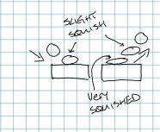

- Default color will be white, but if there is a multiplayer version, 4 colors will be available. White, red, cyan, yellow. Each player can choose one of those colors. One player game will be white only.

